|  |  |
| --- | --- |
|  | **FPT ACADEMY INTERNATIONAL**  **FPT – APTECH COMPUTER EDUCATION** |



**Centre Name: ACE-HCMC-2-FPT.**

**Address: 590 Cach Mang Thang 8, District 3, Ho Chi Minh City, Viet Nam.**

**NAIL ART**

|  |  |  |
| --- | --- | --- |
| **Supervisor** | Mr. Nguyen Phat Tai | |
| **Batch** | T1.2011.M0 | |
| **Group.** | 5 | |
| **Serial No.** | Enrollment Number | Student Name |
| 1. | Student1288146 | Le Ngan Tam |
| 2. | Student1286315 | Nguyen Thi Anh Thu |
| 3. | Student1288148 | Huynh Minh Phat |
| 4. | Student1275242 | Pham Duy Nhan |

**This is to certify that**

**Mr and Mrs:**

Le Ngan Tam

Nguyen Thi Anh Thu

Huynh Minh Phat

Pham Duy Nhan

**Has successfully designed & developed:**

eProject: Nail Art Website

**Submitted by:**

Le Ngan Tam

**Date of issue:**

29- Mar - 2021

**Authorized Signature:**

Le Ngan Tam



**TABLE OF CONTENTS**

FPT – APTECH COMPUTER EDUCATION 1

ACKNOWLEGMENT 3

SYNOSIS 3

PROBLEM DEFINTION 3

CUSTOMER’S REQUIREMENTS SPECICATION (CRS) 4  
Business/Project Objective: 4  
Hardware/Software Requirements: 5

SCOPE OF THE WORK (IN BRIEF) 6

ARCHITECTURE AND DESIGN OF THE SYSTEM 7

DIAGRAM OF THE WEBSITE 8

TASK SHEET REVIEW 1 9

SITE MAP 10

MOCK OF THE WEBSITE 11  
 Home Page 11  
 About us 12  
 Product 13  
 Accessories 14  
 Library 15  
 News 16  
 Contact 17

TASK SHEET REVIEW 2 18

# ACKNOWLEGMENT

To complete this project first of all, I would like to send to fpt aptech's teachers sincere thanks.

In particular, I would like to send to Mr. Nguyen Phat Tai, the teacher who has dedicatedly guided and helped me complete the project with kindness and seriousness, and he creates conditions for us to learn a lot of knowledge to complete the project. Besides, I would like to thank all members of the 5 team, each working hard for 4 weeks to complete this project

Thank you!

# SYNOSIS

Here we are aiming to design a website “NailArt” which will provide an easy way to learn nail art with various designs and steps involved Art.

# 

# PROBLEM DEFINITION

The Web site is to be created based on the following requirements.

1. The home page must describe the keywords or highlight the nail art designs with all navigation links defined.
2. The site should provide the brief information about nailart as from where it originated etc.
3. There should be a well designed menu with necessary sub menu options.
4. There should be various categories (forms and styles) like easy to design for kids, complex for elders.
5. There should also be categories of designs as Faces, geometric design, flowers etc. Minimum 5 categories are expected here.
6. Proper description of the design along with the image and steps must be added in the website.
7. Along with the nailart designs there should be a section which will showcase the various products and accessories for art like nail polish etc
8. Also there should be a section giving information about nail care.
9. About Us
10. Contact us page: contact us details with location should be displayed using GeoLocation API (eg. GoogleMaps).
11. Feedback form
12. Gallery section should be added.
13. Color combination must be uniform throughout the project.
14. Navigation must be smooth

**CUSTOMER'S** **REQUIREMENTS** **SPECIFICATIONS**

**(CRS)**

**Client: Nail Art**

*Business/Project Objective:*

*Nail art is a creative way to draw, decorate, enhance and adorn nails. It is a kind of artwork that can be done on nails and pedicures, usually after nail or pedicure repair paint. Manicure and pedicures are beauty methods that help trim, shape and polish nails. Most often, these procedures remove the epidermis and soften the skin around the nails. Nail polishes can vary, from glossy paint on natural nails to dip powder and acrylic nails.

*The nail care industry has grown more than ever since the invention of modern nail polish.

*The art of nail painting is also a way to create its own identity through fashion, using color and shape as a disruption of childhood and entering the teenage/adult world of women, also leaving the influence of their parents to create themselves.

**Output from the system:**

A menu that will categorize all the functions of the site.

Display the list of available albums category wisely.

Perform the search based on a particular: brands, type of Nail Art

Site should be able to provide brief introduction/history about the showroom under About Us page.

The location of the showroom under Contact-Us page.

Besides the above requirements, the site should have look and feel as per the industry standards.

**Expected delivery date:** 29-Mar-2021.

**List of deliverables:**

- Document Word.

- User Guide.

- Source code.

*Hardware/Software Requirements:*

**Hardware:**

• The minimum computer system that will give you access to all the tools in the courses is Pentium 166 or higher

• 64 Megabytes of RAM or more

**Software:**

* Notepad/HTML editor
* Dreamweaver
* IE 5.0/ Netscape 6.0.

**For web users**

**Hardware:**

* Intel Pentium 4 processor or higher
* 512 Megabytes of RAM or higher

**Software:**

* Windows XP OS or higher
* Web browsers such as IE, Chrome or Firefox are supporting HTML5, CSS3 and Javascript.

.

# SCOPE OF THE WORK (IN BRIEF)

After a long and detailed discussion, our group has decided to create a website contain the following webpages:

1. **Hompage:** Show off the latest best-selling nail products, introduce Nail Art

2. **About us:** Show company information and about us

3. **Product:** Display nail products and nail tools

4. **Accossories:** Display nail accessories

5. **Library:** Display nail images for reference

6*.***News:**Nail news and nail care

# 7. Contact: Displays the company address, allowing customers to request any information they want from Nail Art

**ARCHITECTURE AND DESIGN OF THE SYSTEM**

Webpage request

WEB SEVER

WEB BROWSER

**Requested Page**

REDERNING

ENGINE



HTML

JAVASCRIP

JQUERY

CSS CODE

BOOSTRAP

# Diagram of the website

ABOUT US

PRODUCT

ACCESSORIES

LIBRARY

NEWS

CONTACT

.

HOME



# TASK SHEET REVIEW 1

|  |  |  |  |  |  |  |  |
| --- | --- | --- | --- | --- | --- | --- | --- |
| **Project Ref. No.:**  **eP/Advertisement Portal Management**  **System/01** | | **Project Title:** | **Activity Plan Prepared By:** | **Date of Preparation of Activity Plan:** | | | |
| **Sr.**  **No.** | **Task** | **Actual**  **Start Date** | **Actual Days** | **Team**  **Mate Names** | **Status** |
| 1 | Problem Statement | Nail Art | Tam | 07-Mar-2021 | 1 | Tam | Completed |
| 2 | Analysis of Nail Art requirements about the website | 07-Mar-2021 | 1 | Thu | Completed |
| 3 | The scope of the work (in brief) | 07-Mar-2021 | 1 | Nhân | Completed |
| 4 | Architecture and design of the system | 07-Mar-2021 | 1 | Phat | Completed |
| 5 | Diagram of the website | 07-Mar-2021 | 1 | Phat,Thu  Nhan | Completed |
| 6 | Task Sheet | 07-Mar-2021 | 1 | Tâ\am | Completed |

|  |  |
| --- | --- |
| **Date:08/03/2021** | |
| Signature of Instructor:  **Mr. Nguyen Phat Tai** | Signature of Team Leader:  **Le Ngan Tam** |

# SITE MAP

ABOUT US

PRODUCT PAGE

PRODUCT

ABOUT US PAGE

HOME

PAGE

HOME

LIBRARY

LIBRARY

PAGE

NEWS

NEWS PAGE

NEWS PAGE

NEWS

ACCOSSORIES

PAGE

ACCOSSORIES

# MOCK OF THE WEBSITE

1. **Homepage:**

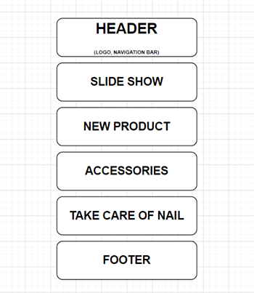

1. **About us:**

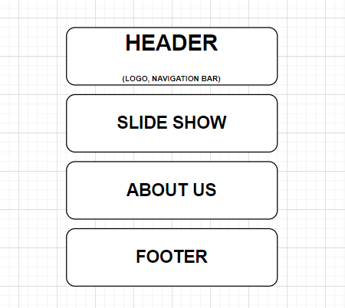

1. **Product:**

# 

1. **Accessories:**

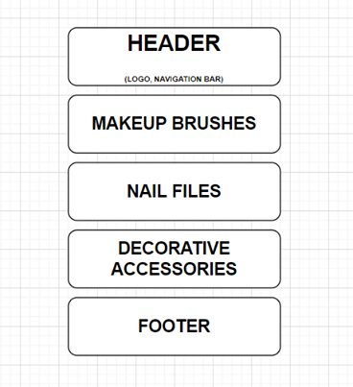

1. **Library:**

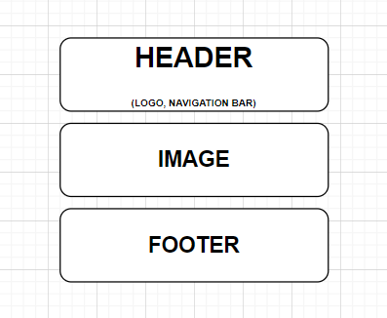

1. **News:**

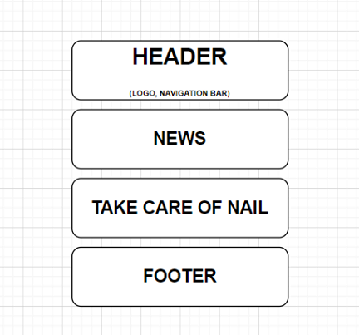

# Contact:

# 

# TASK SHEET REVIEW 2

|  |  |  |  |  |  |  |  |
| --- | --- | --- | --- | --- | --- | --- | --- |
| **Project Ref. No.:**  **eP/Advertisement**  **Portal Management System/01** | | **Project Title:** | **Activity Plan Prepared By:** | **Date of Preparation of Activity Plan:** | | | |
| **Sr.**  **No.** | **Task** | **Actual Start Date** | **Actual Days** | **Team Mate Names** | **Status** |
| 1 | Site map | Nail Art | Tam | 10-Oct-20 | 1 | Thu, Tam | Completed |
| 2 | Mock of the website | 10-Oct-20 | 2 | Nhan, Phat | Completed |
| 3 | Task sheet | 10-Oct-20 | 2 | Tam | Completed |

|  |  |
| --- | --- |
| **Date:15/03/2021** | |
| Signature of Instructor:  **Mr. Nguyen Phat Tai** | Signature of Team Leader:  **Mrs. Le Ngan Tam** |

# WEBSITE DESCRIPTION

**HOMEPAGE:**

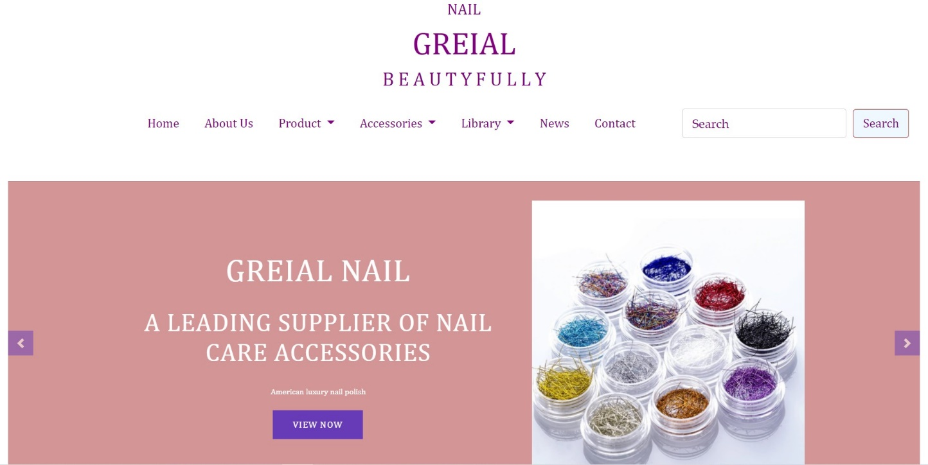

PRODUCT:

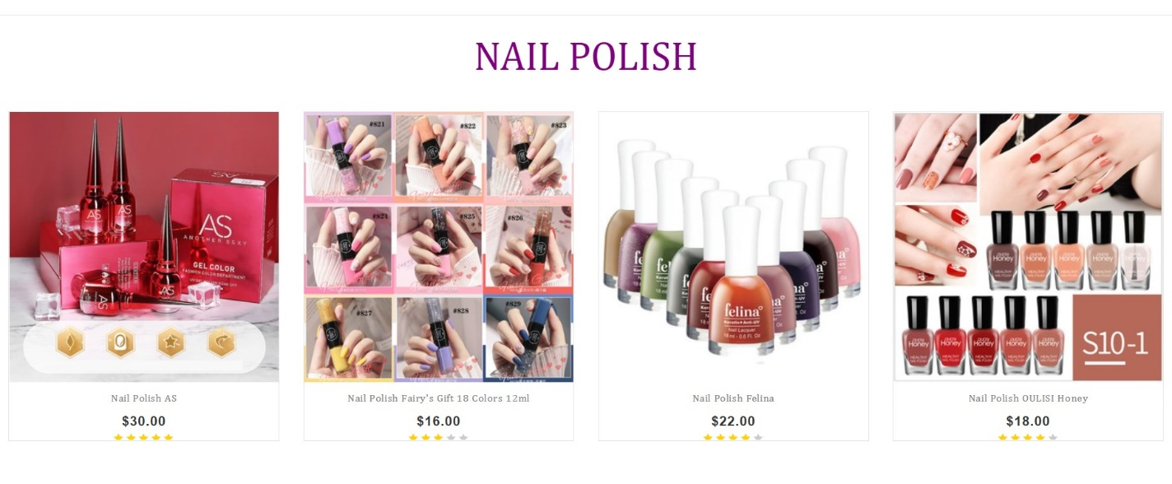

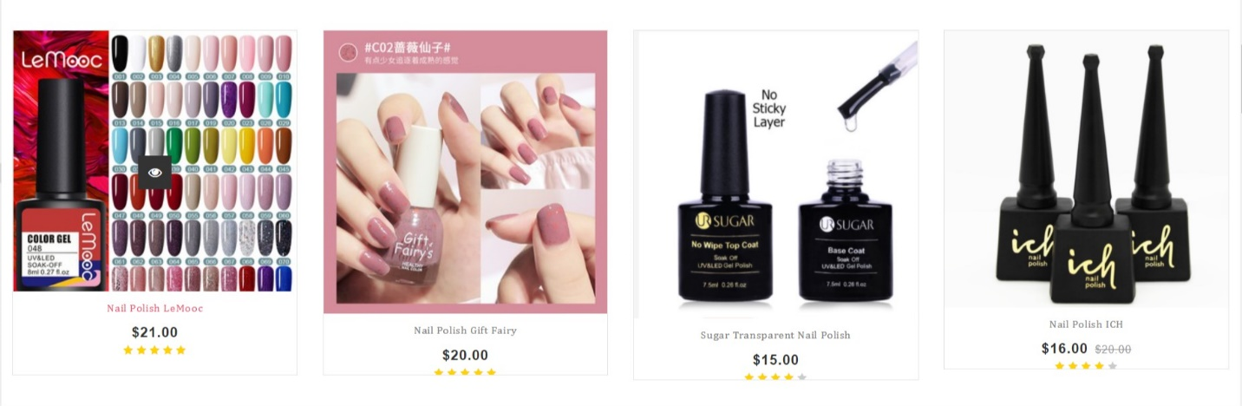

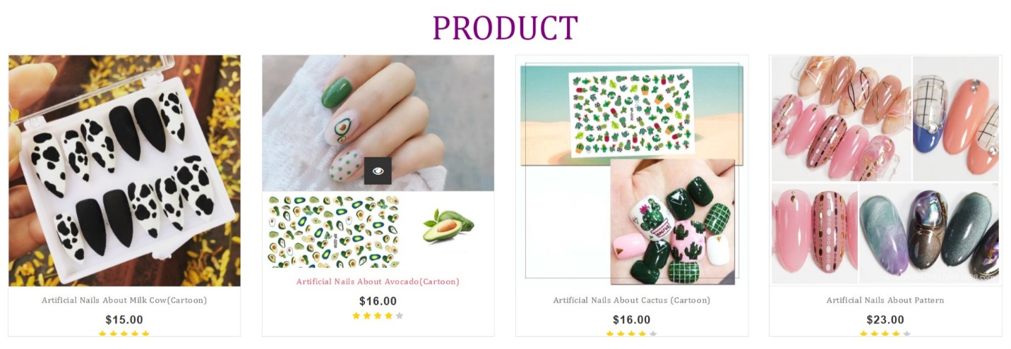

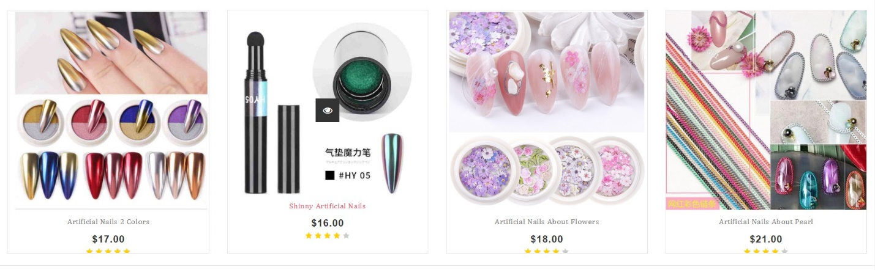

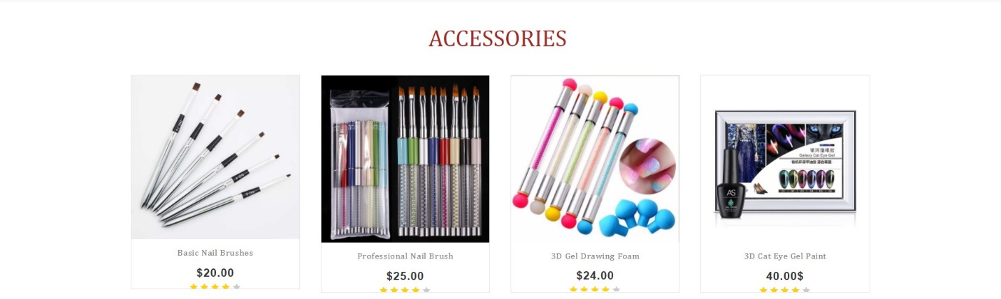

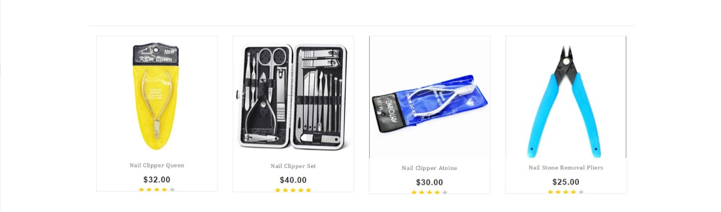

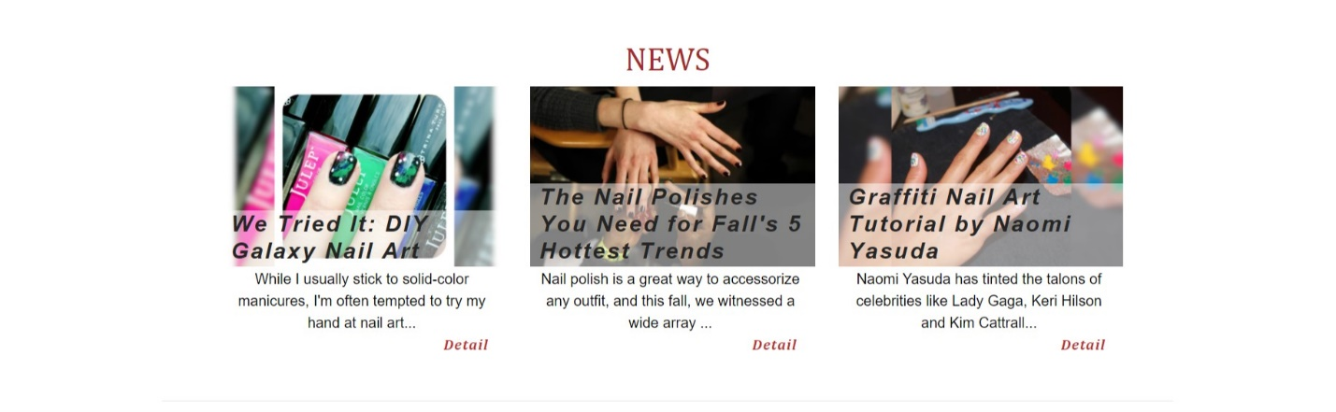

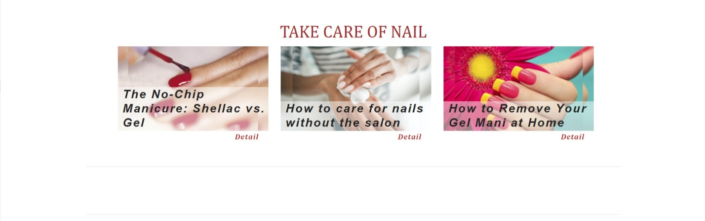

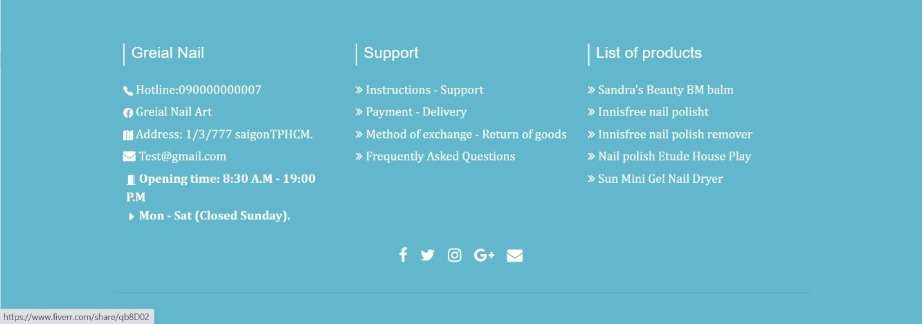

**ABOUT US:**

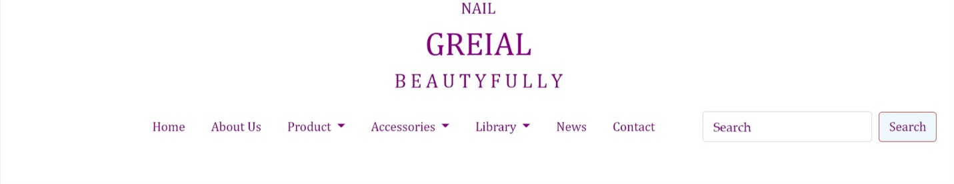



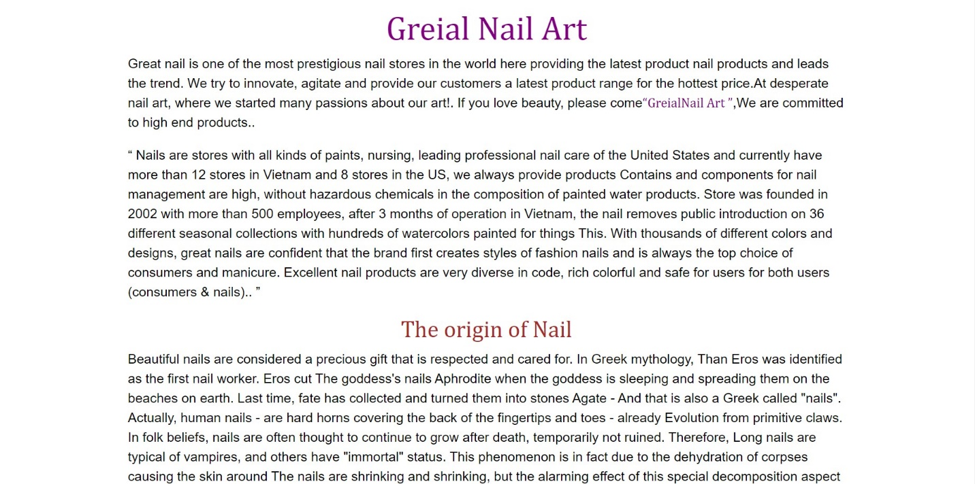

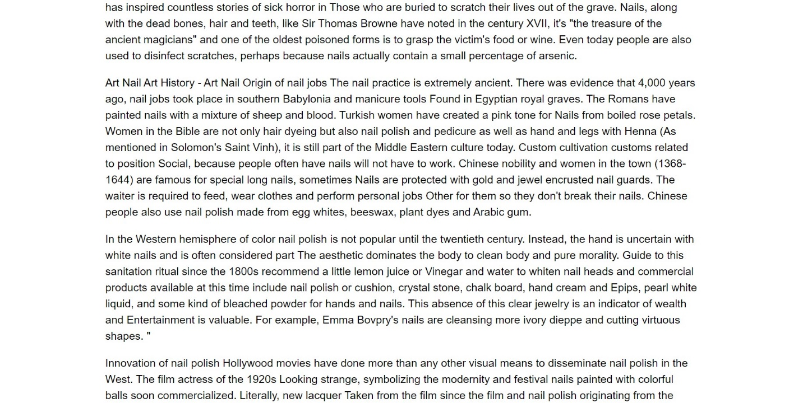

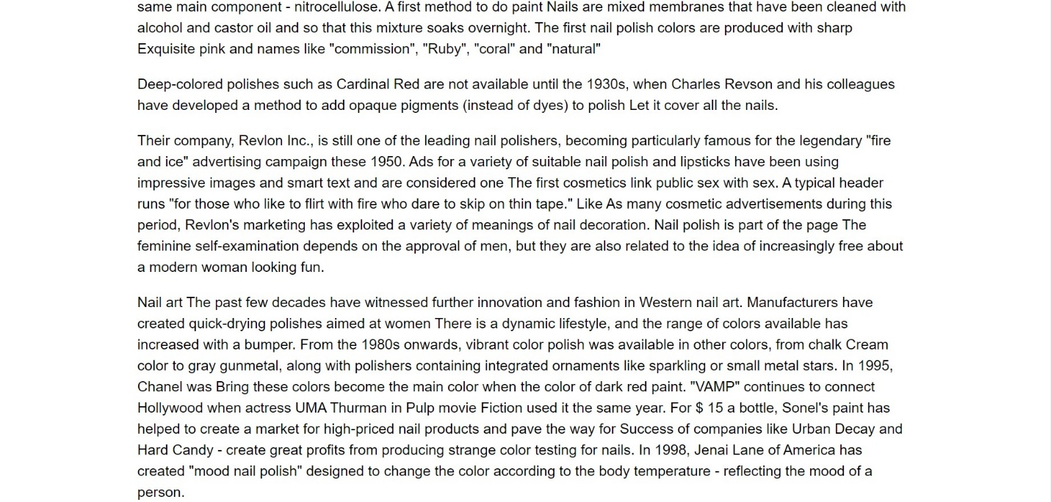

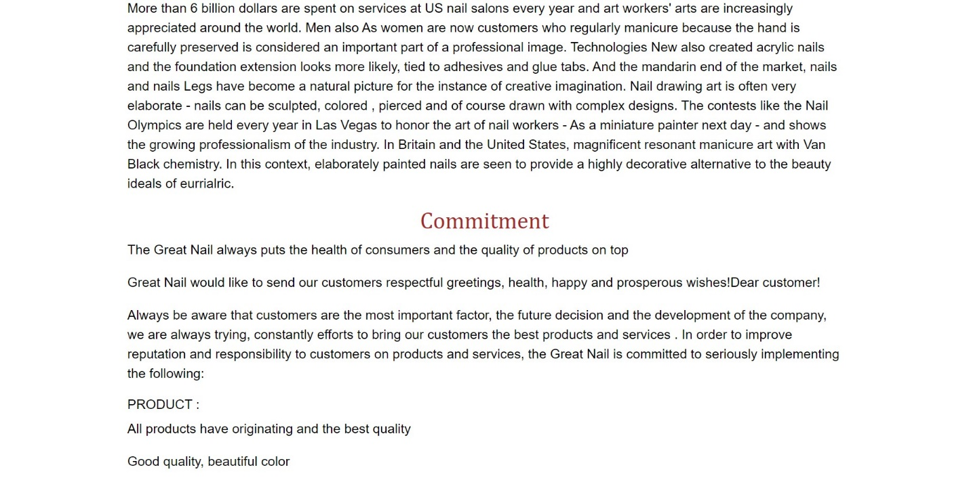

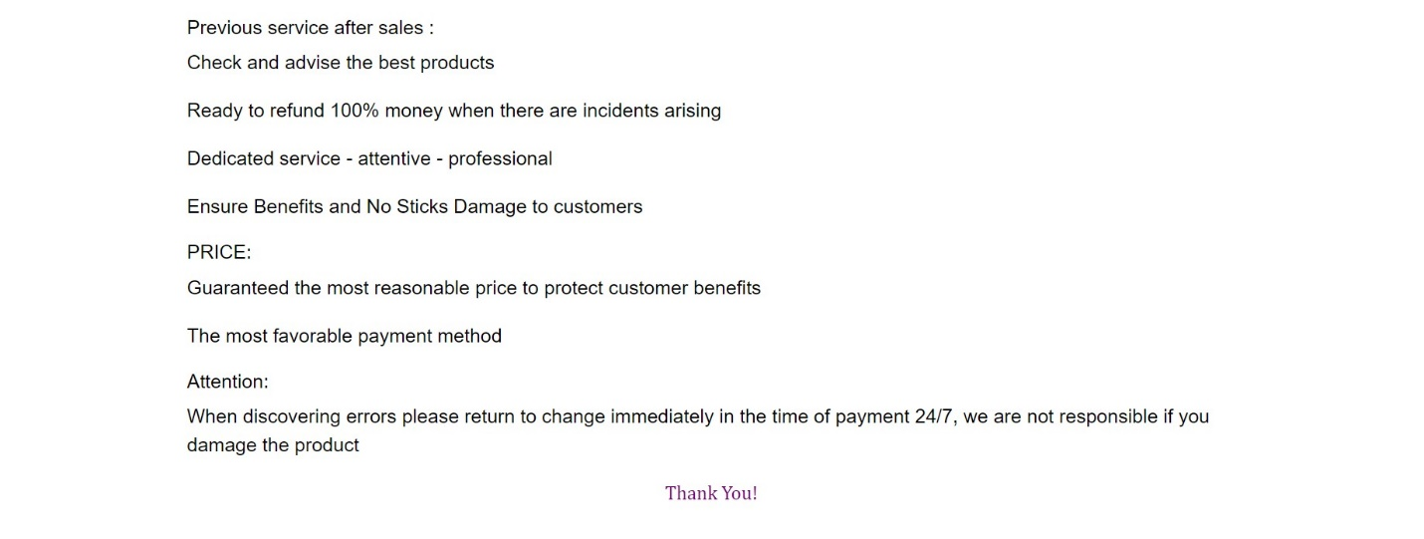

**PRODUCT:**



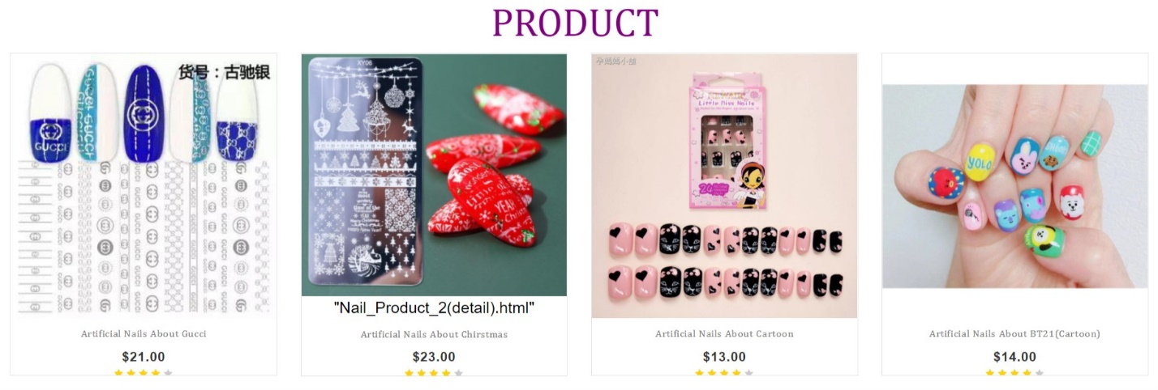

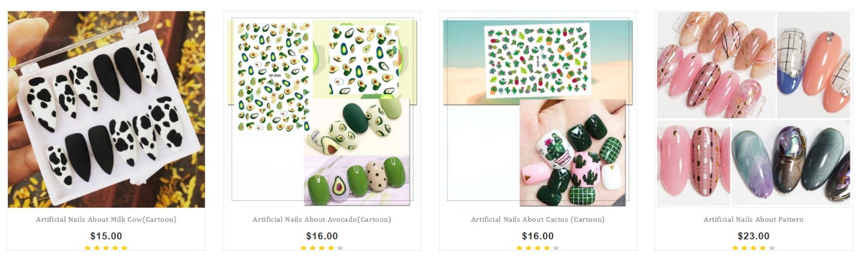

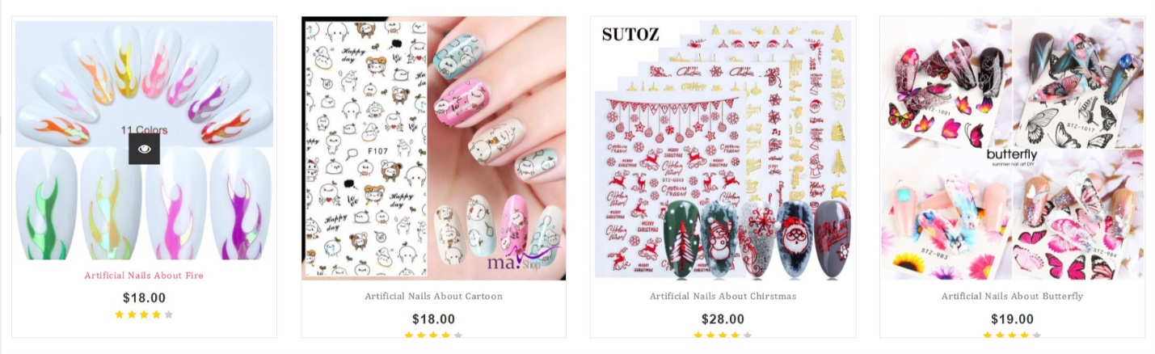

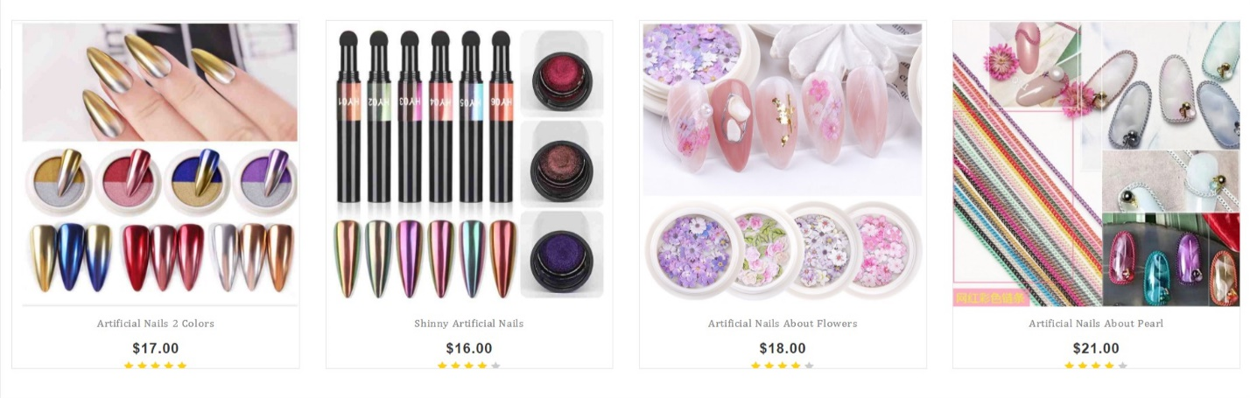

**DETAIL PRODUCT:**

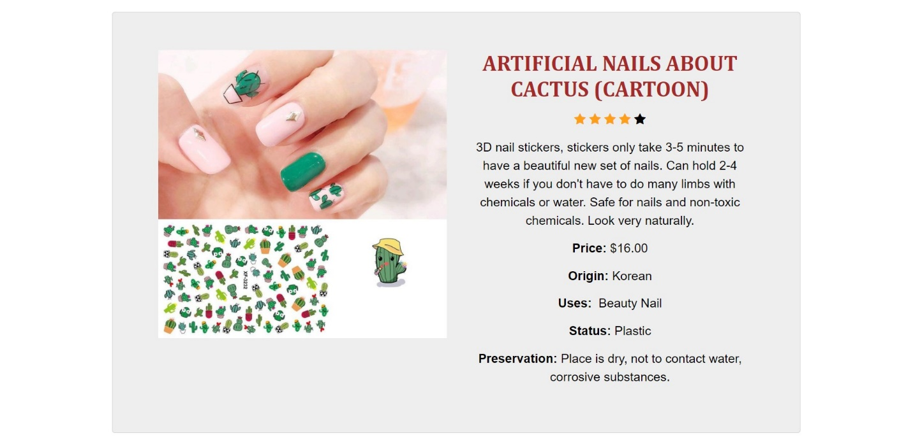

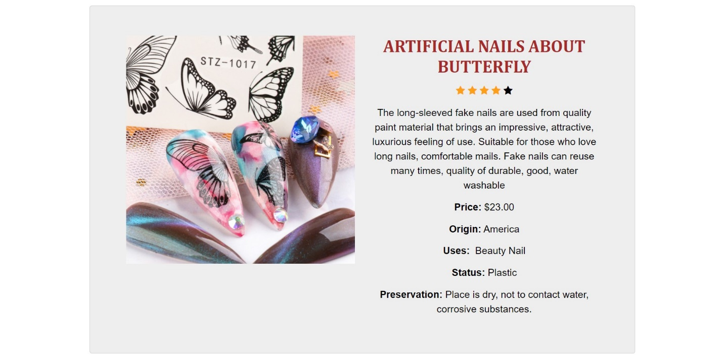

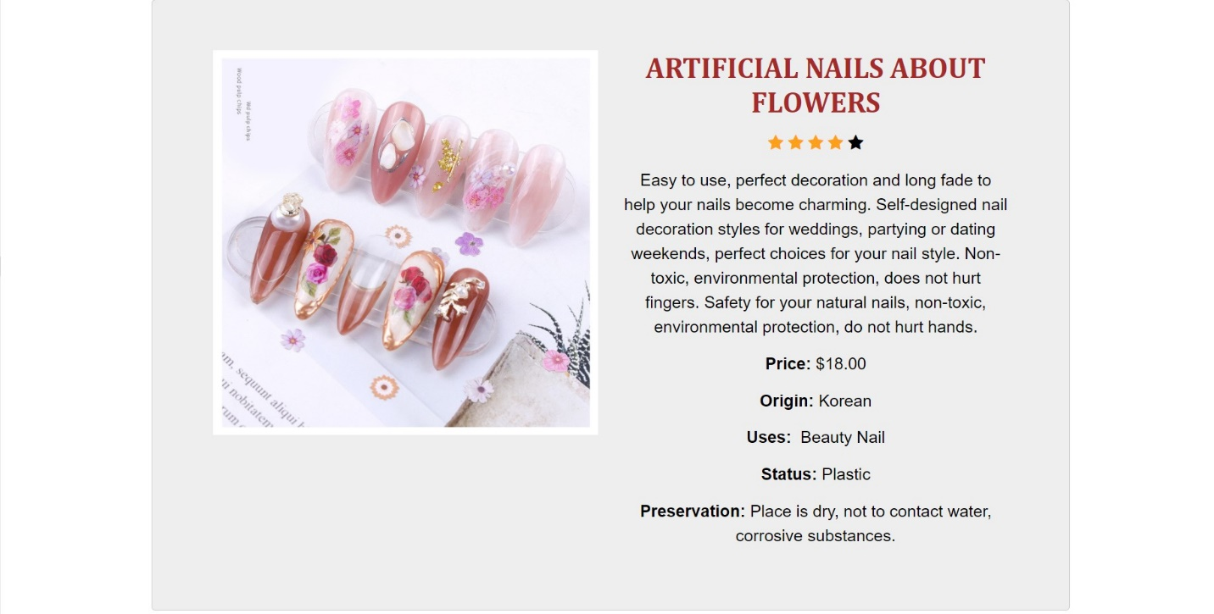

**NAIL POLISH (PRODUCT):**

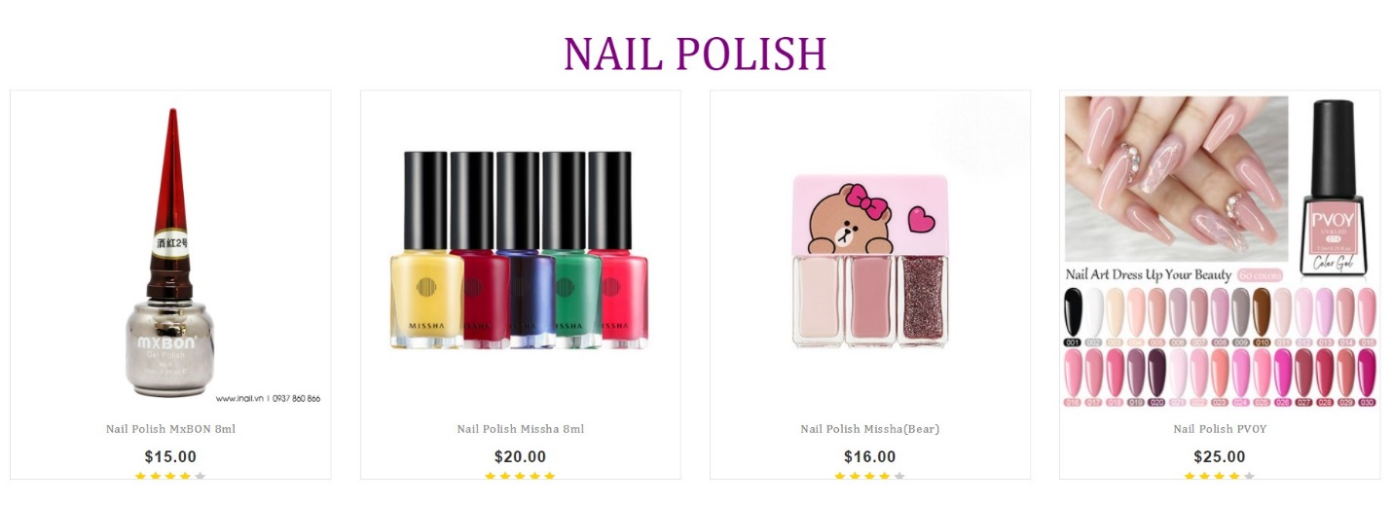

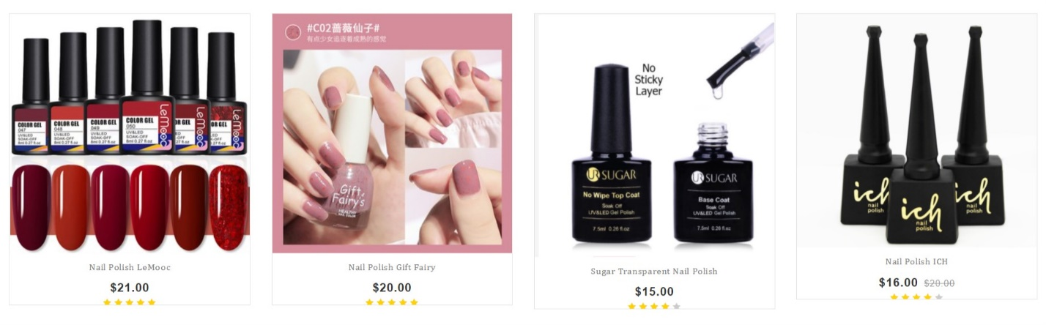

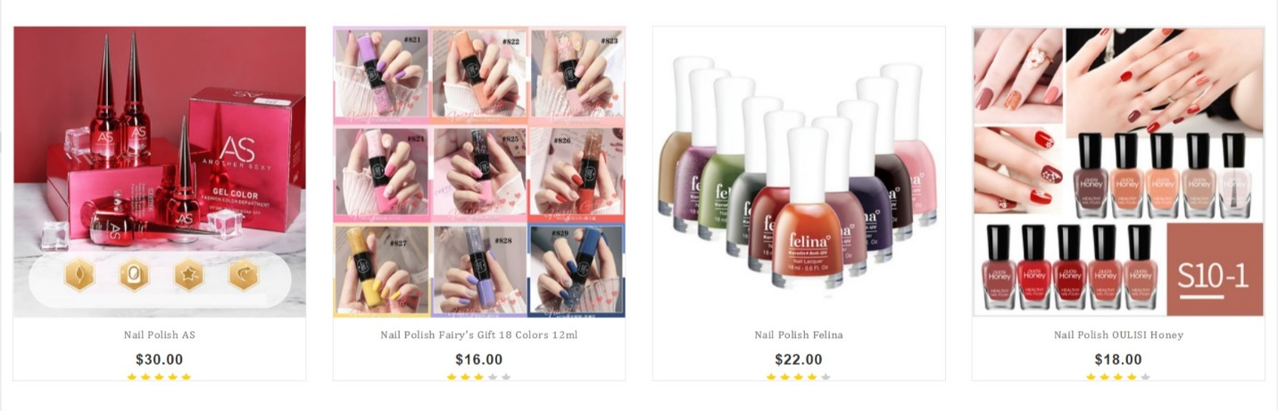

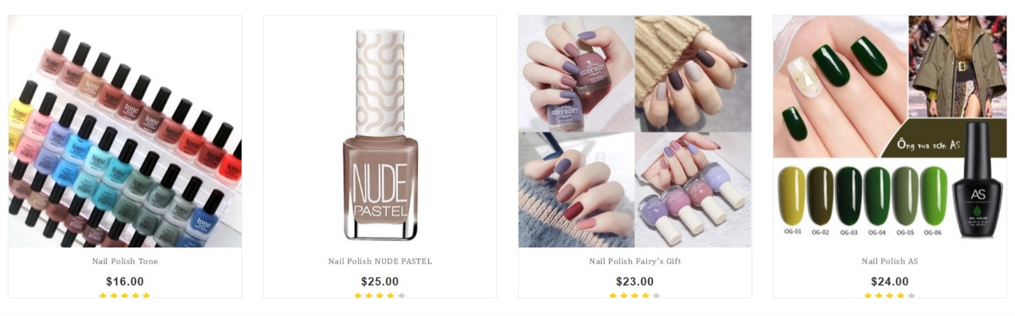

**ACCESSORIES:**

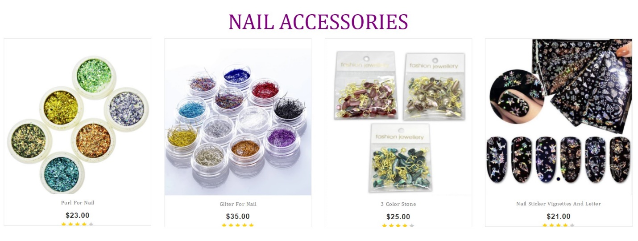

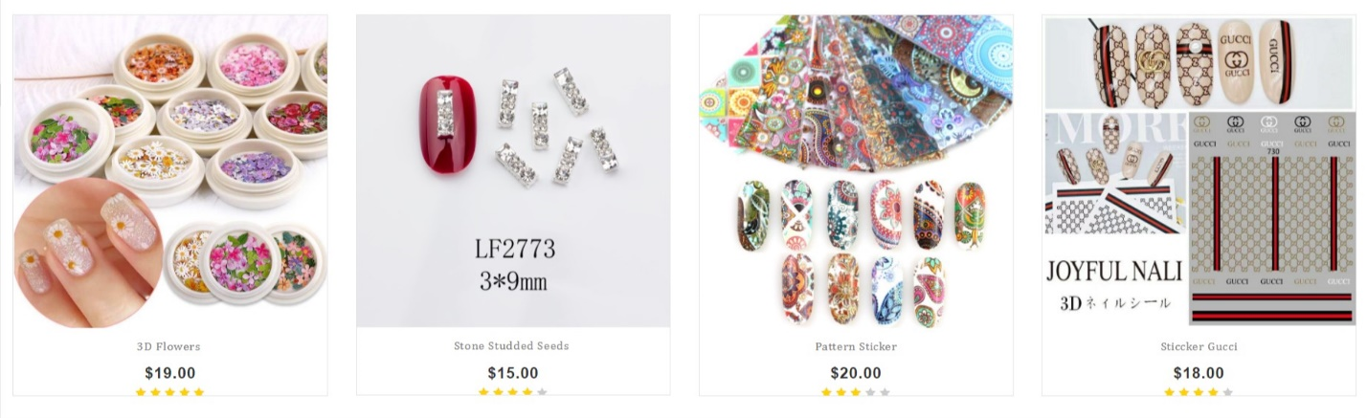

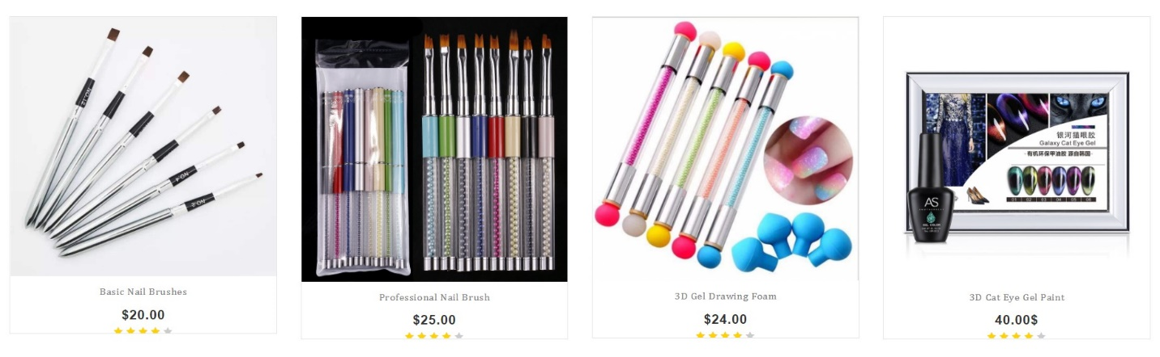

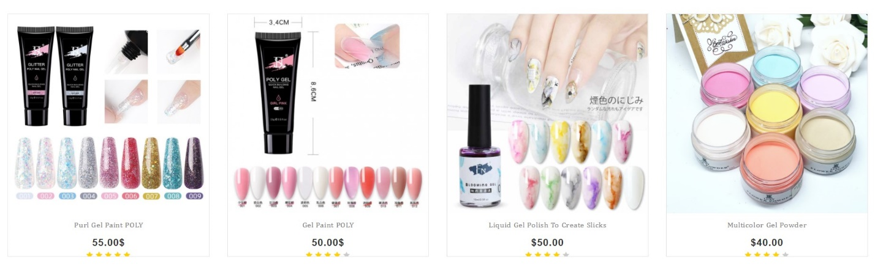

**DETAIL ACCESSORIES:**

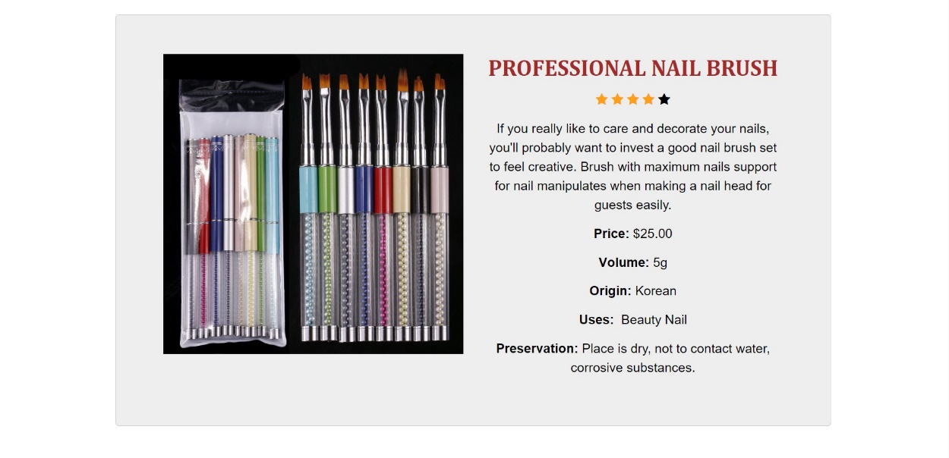

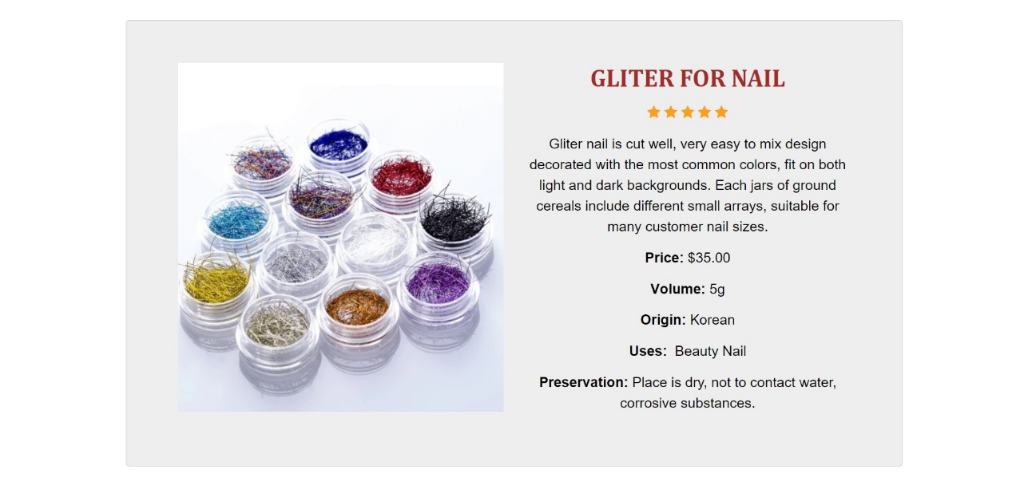

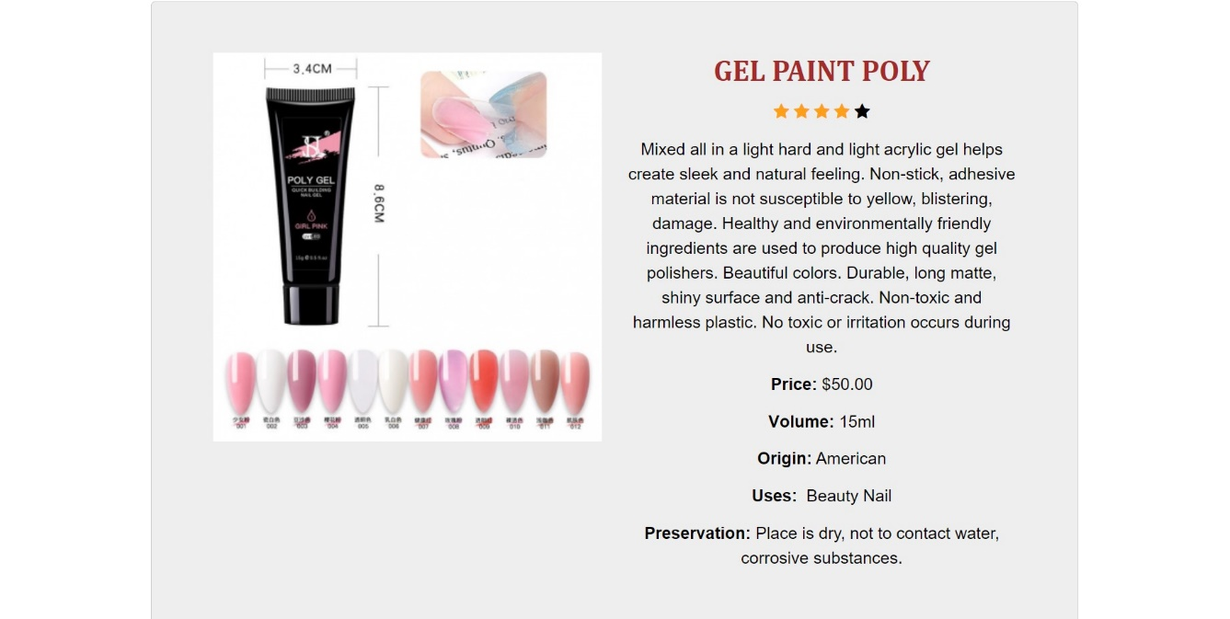

**NAIL CARE ACCESSORIES (ACCESSRORIES):**

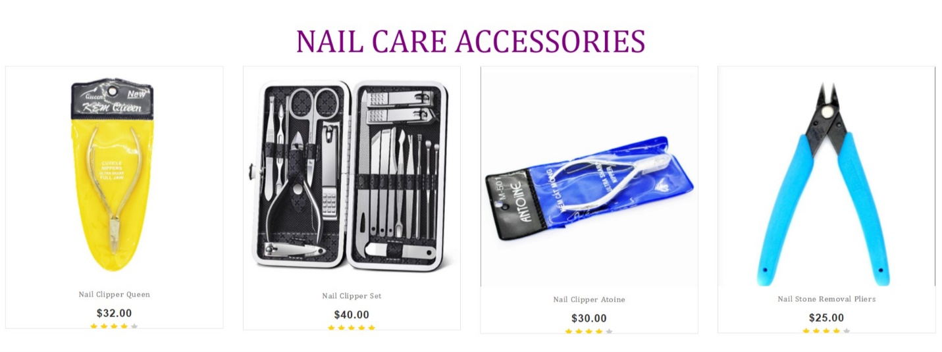

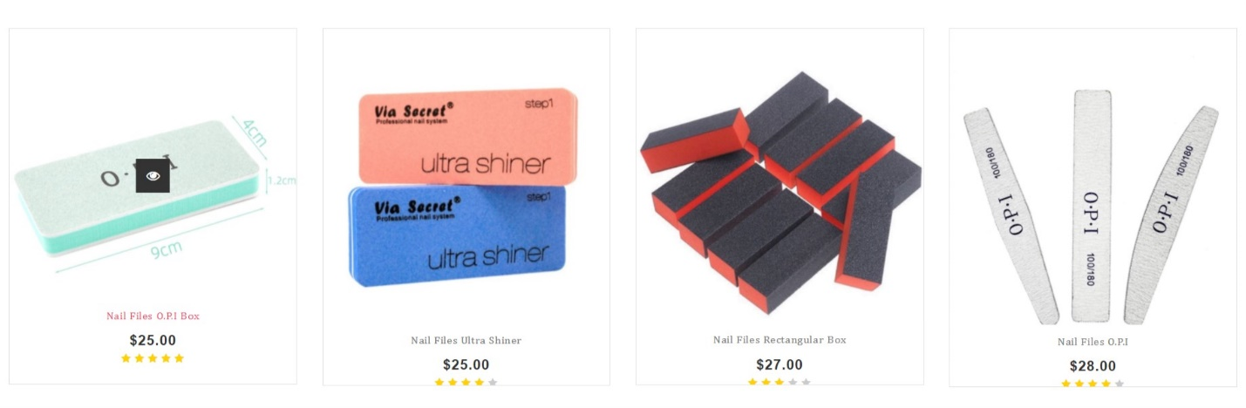

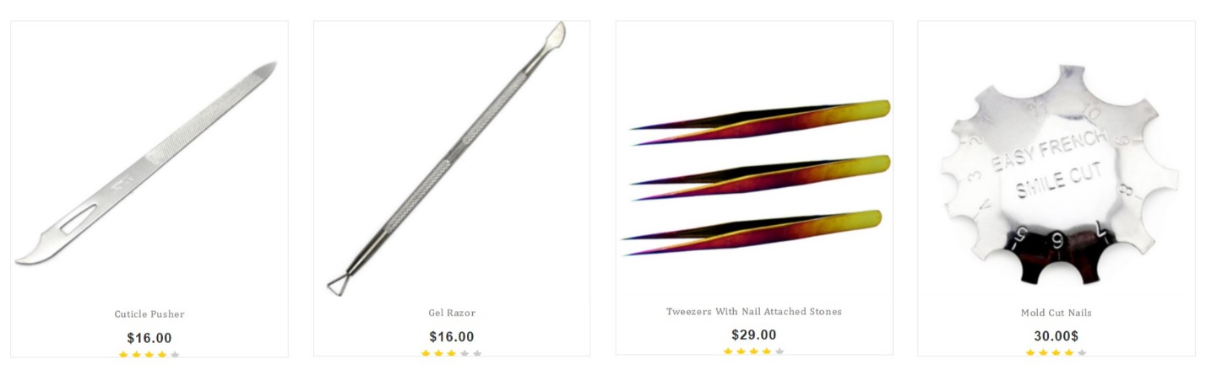

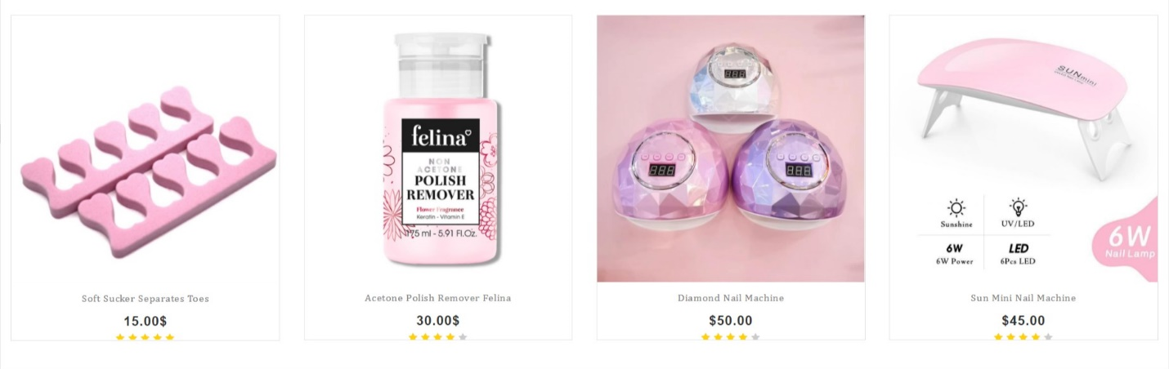

**DETAIL NAIL CARE ACCESSORIES (ACCESSRORIES):**

# 

# 

# 

**LIBRARY:**

# 

# 

**LIBRARY:**

# 

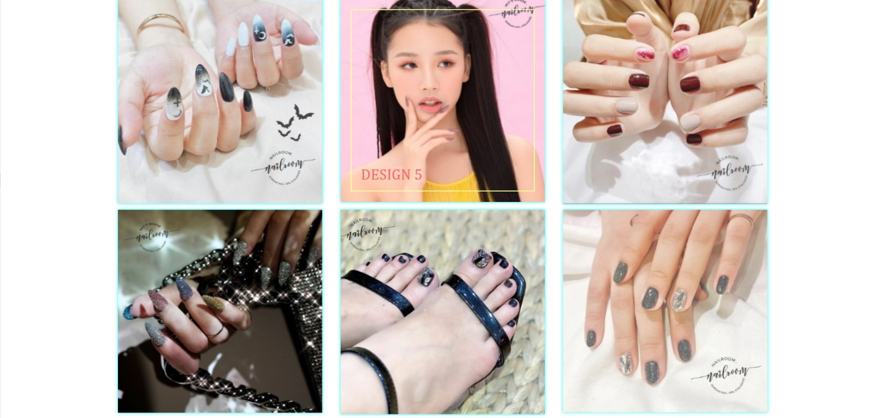

**NEWS:**

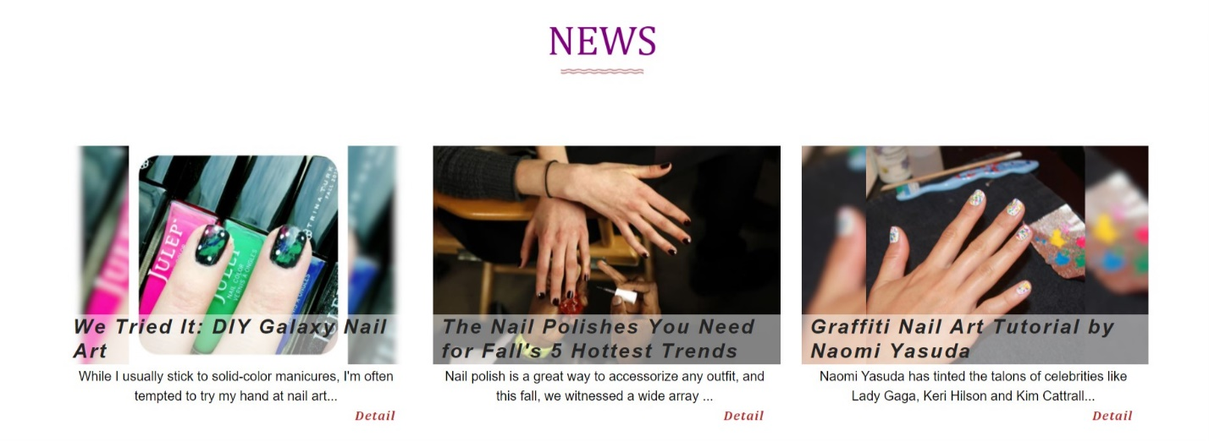

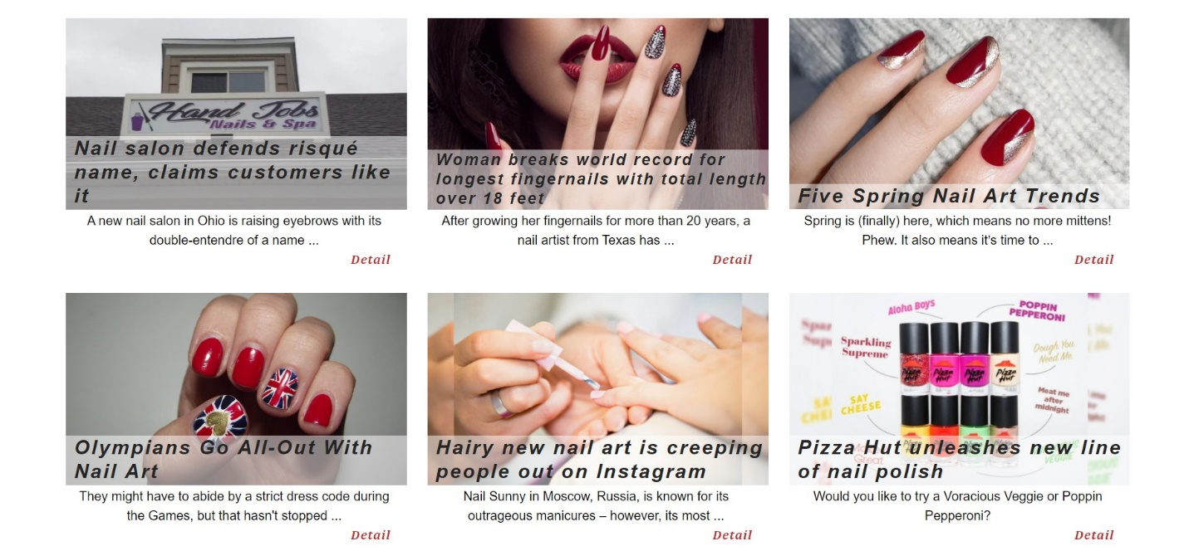

**CONTACT:**

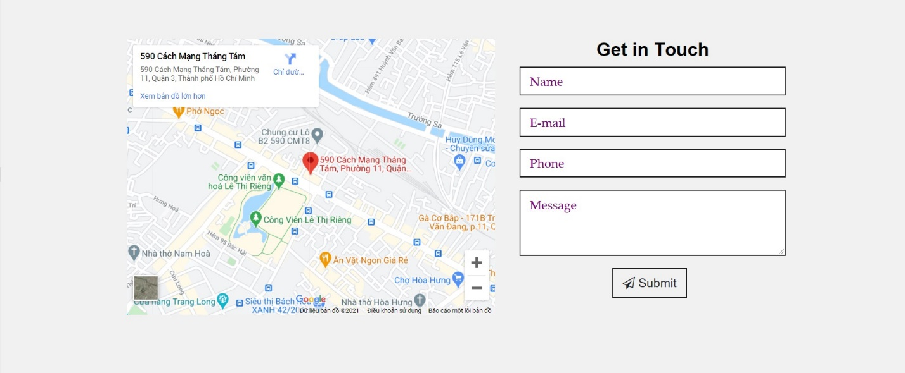

# TASK SHEET REVIEW 3

|  |  |  |  |  |  |  |  |
| --- | --- | --- | --- | --- | --- | --- | --- |
| **Project Ref. No.:**  **eP/Advertisement Portal Management System/01** | | **Project Title:** | **Date of Preparation of Activity Plan:** | | | | |
| Sr.No | Task | **Activity Plan Prepared By:** | **Actual Start**  **Date** | **Actual Days** | **Team Mate**  **Names** | **Status** |
| 1 | **HOME** | Nail Art | Tam | 28/3/2021 | 5 | Thu, Phat | Completed |
| 2 | **ABOUT US** | 28/3/2021 | 2 | Thu | Completed |
| 3 | **PRODUCT** | 28/3/2021 | 5 | Tam | Completed |
| 4 | **ACCESSORIES** | 28/3/2021 | 5 | Tam | Completed |
| 5 | **LIBRARY** | 28/3/2021 | 2 | Tam, Nhan | Completed |
| 6 | **NEWS** | 28/3/2021 | 3 | Nhan | Completed |
| 7 | **CONTACT** | 28/3/2021 | 2 | Phat | Completed |

|  |  |
| --- | --- |
| **Date: 22/3/2020** | |
| Signature of Instructor:  **Mr. Nguyen Phat Tai** | Signature of Team Leader:  **Mrs. Le Ngan Tam** |